Select date

SELECT ENFORCEMENT AGENCY

Re: Security Clearance for Rotary District 5360 Volunteers
involved in Youth and/or Vulnerable Sector Programs

Rotary International is a worldwide service club organization to which 1.2 million business and professional people serve as volunteers in the community, international and vocational service in 31,000 Rotary clubs in 133 countries.

Any adult involved with Rotary’s Programs serving the youth or vulnerable sectors who has direct interactions regularly, supervised or unsupervised, is considered a volunteer. Volunteers include, among others, Club and District Officers, Youth Service officers and committee members, Youth Exchange Counsellors, Rotarians and non-Rotarians and their spouses and partners who host youth for activities or outings, host parents and other adult residents residing in the host home, including siblings over 15 years old.

All volunteers over 18 years old and interested in participating in District 5360 Volunteer Programs for youth/vulnerable must have a valid and current Police or RCMP Information Check, including Vulnerable Sector Screening. Volunteers under 18 years of age do not require a Vulnerable Sector Screening.

enter full legal name is an UNPAID VOLUNTEER of
Rotary Club of / Rotary Youth Program CHOOSE CLUB/PROGRAM
in Rotary International District 5360 with the position of SELECT VOLUNTEER ROLE and requires screening that includes a Vulnerable Sector Check.

Please accept this letter as confirmation of those named above and their status as a Rotary District 5360 / Rotary Club Youth Service Program / Vulnerable Sector volunteer.

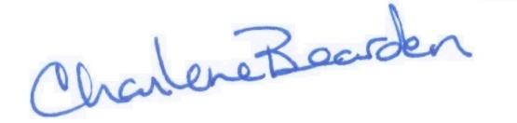
Sincerely,

Charlene Bearden
District Administrator
Rotary District 5360

